Peter Emmanuel Barredo

1. Creating “**orderitem**” table

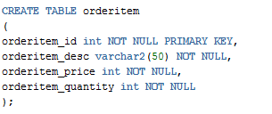

Creating “**users**” table

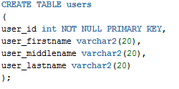

Creating “**orderTable**” table

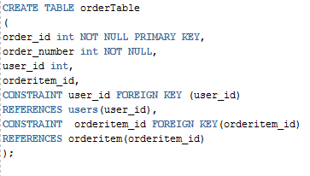

1. DQL Commands – Data Query Language . This is use for fetching data to the database using select statements.

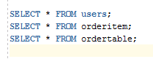

DML Commands – Data Manipulation Language . Used for changing data within the database.

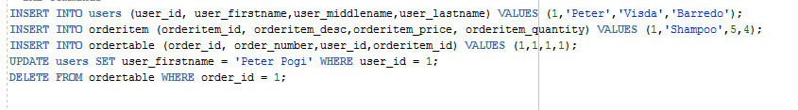

DDL Commands – Data Definition Language. It used to create,delete and modify the database structure.

Create

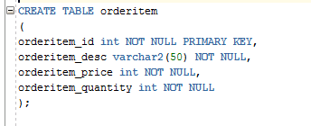

Drop

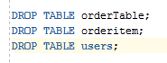

Rename



Alter



DCL Commands – Data Control Language. Used to control access to data and database.

Grant



Rollback



Commit



Revoke

